Part Number: PT29A-78150-XX
Kit Contents
Item # | Quantity Reqd. | Description
1 | 1 | Molding, LH Front Door
2 | 1 | Molding, LH Rear Door
3 | 1 | Molding, RH Front Door
4 | 1 | Molding, RH Rear Door
Hardware Bag Contents
Item # | Quantity Reqd. | Description
1
2
Additional Items Required For Installation
Item # | Quantity Reqd. | Description
1
2
Conflicts
None
Recommended Tools
Personal & Vehicle Protection | Notes
Safety Glasses
Seat & Floor Covers
Special Tools | Notes
Roller | Hard Rubber Hand Roller, 1” to 3” wide.
Non intrusive Infrared Temp Probe/Gun
Installation Tools | Notes
Flexible Scale or Tape Measure
Masking Tape | 2” wide
Clean Lint-free Cloths
Straight Edge (Plastic)
Heat Gun (if required to warm surfaces)
Heat Source
Special Chemicals | Notes
Simple Green All Purpose Cleaner | ½ Strength (1 part Simple Green to 1 part water)
General Applicability
Body Side Molding can be installed on all NX/NXh models.
Recommended Sequence of Application
Item # | Accessory
1 | Body Side Molding
2 | Door Edge Guards
*Mandatory

Vehicle Service Parts (may be required for reassembly)
Item # | Quantity Reqd. | Description
Legend
STOP: Damage to the vehicle may occur. Do not proceed until process has been complied with.
OPERATOR SAFETY: Use caution to avoid risk of injury.
CAUTION: A process that must be carefully observed in order to reduce the risk of damage to the accessory/vehicle and to ensure a quality installation.
TOOLS & EQUIPMENT: Used in Figures calls out the specific tools and equipment recommended for this process.
REVISION MARK: This mark highlights a change in installation with respect to previous issue.
SAFETY TORQUE: This mark indicates that torque is related to safety.

Care must be taken when installing this accessory to ensure damage does not occur to the vehicle. The installation of this accessory should follow approved guidelines to ensure a quality installation.

These guidelines can be found in the "Accessory Installation Practices" document.

This document covers such items as:-
- Vehicle Protection (use of covers and blankets, cleaning chemicals, etc.).
- Safety (eye protection, rechecking torque procedure, etc.).
- Vehicle Disassembly/Reassembly (panel removal, part storage, etc.).
- Electrical Component Disassembly/Reassembly (battery disconnection, connector removal, etc.).

Please see your Toyota dealer for a copy of this document.

Prepare the Vehicle.
  - Before working on the vehicle, protect the seats and carpets with covers.
  - The work area, body side moldings, and vehicle door surface temperatures must be at least 60˚F.
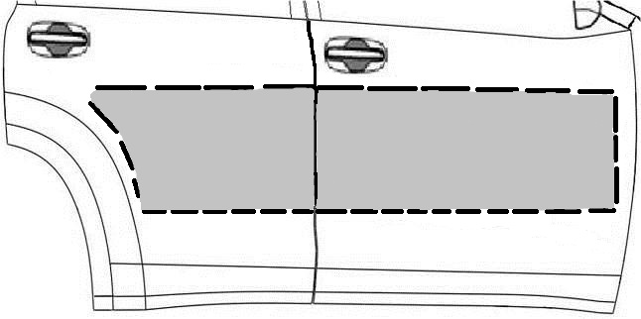
  - Saturate a clean, lint-free cloth with a ½ strength Simple Green solution (1 part Simple Green to 1 part water) and clean the areas of each door as shown in Fig. 1-1.
Fig. 1-1
  - Wipe the cleaned surfaces with a clean, dry, lint-free cloth.
NOTE: Once cleaned do not contaminate this surface by touching it with your bare hands.

Apply Alignment Tape.
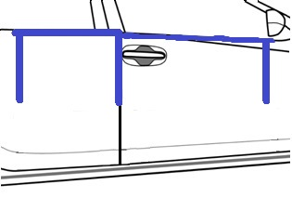
  - Place tape across the top edge of the front and rear doors (Fig. 2-1).
Fig. 2-1
690mm
265mm
Approx. 450mm long
Tape
  - Measure 690mm forward from the top rear edge of the front door and place a vertical piece of tape on the front door approximately 450mm long (Fig. 2-1).
  - Place a vertical piece of tape over the door gap between the front and rear doors approximately 450mm long (Fig. 2-1).
  - Measure 265mm rearward from the front top edge of the rear door and place a vertical piece of tape on the rear door approximately 450mm long (Fig. 2-1).
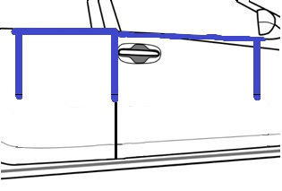
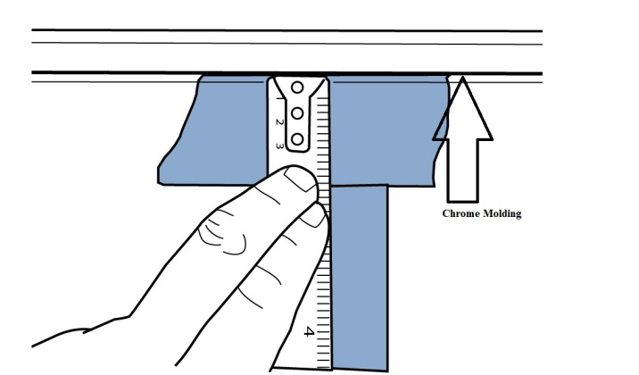
  - Measure down from the bottom of the chrome window molding (Fig. 2-2) and place a horizontal mark on the three vertical pieces of tape (Fig. 2-3).
Fig. 2-3
420mm
409mm
380mm
Marking pen
Front
Fig. 2-2
Tape measure
Chrome molding
    - Front: 380mm
    - Middle: 409mm
    - Rear: 420mm

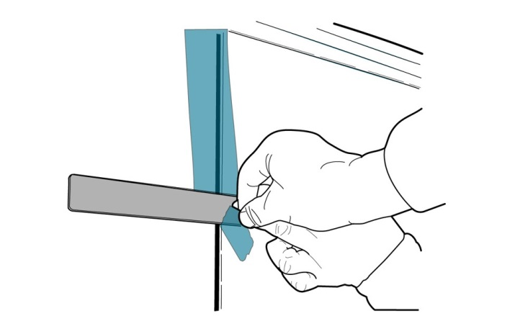
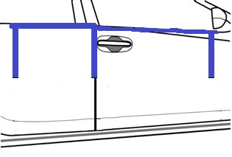
  - Use a straight edge to tear the vertical tape along the horizontal line at the lower mark (Fig. 2-4 & Fig. 2-5).
Fig. 2-4
Straight edge
Fig. 2-5
  - Repeat Steps 2(a) to 2(f) for the other side of the vehicle.

Install the Body Side Molding.
  - The inside of each of the four moldings is identified as to their correct position on the vehicle.
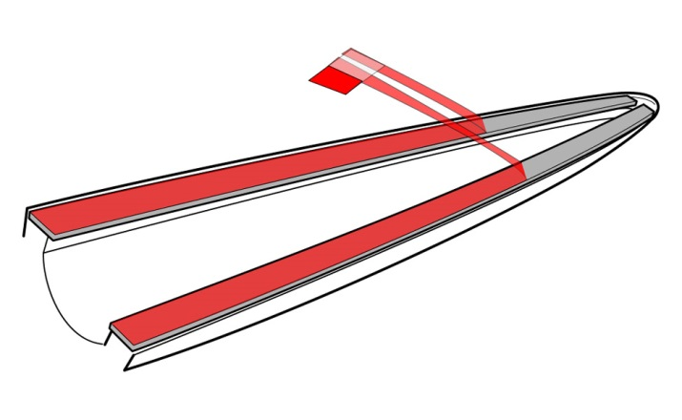
  - Start with the RH front door molding. While carefully holding the molding by its edges, pull the plastic tape at the end of the part to remove the orange release liner from the grey acrylic foam tape strips (Fig. 3-1).
Fig. 3-1
RH Front Molding
NOTE: Once the release liner is removed from the molding, the surface of the foam tape must not be touched!

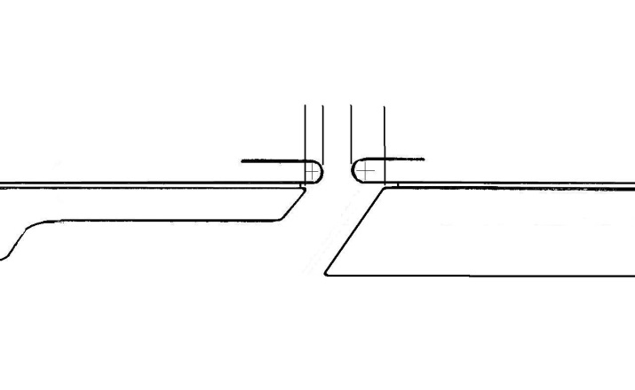
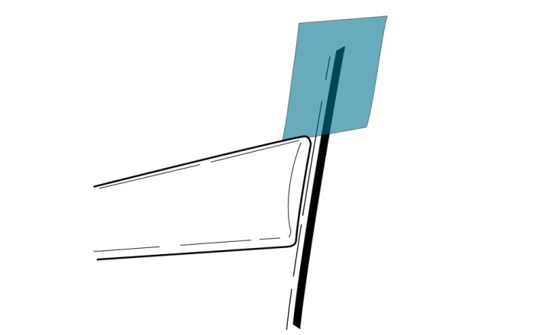
  - Hold the molding about ½” from the surface of the front door and align the rear edge of the molding 6.0 mm from the rear edge of the front door (Fig. 3-2 & Fig. 3-3).
6.0mm (0.24”)
3.0mm (0.12”)
Fig. 3-3
Rear Door

Rear Molding
Front Molding
Front Door
Fig. 3-2
    - The rear top edge of the molding aligns vertically with the bottom edge of the vertical tape strip.
    - The front portion of the molding aligns with the bottom edge of the tape strip at the front of the door.
  - Once the molding is properly aligned, press it to the door surface starting at the rear and working toward the front with a rolling motion.
NOTE: Do not allow both ends to contact and stick to the door before the center contacts.

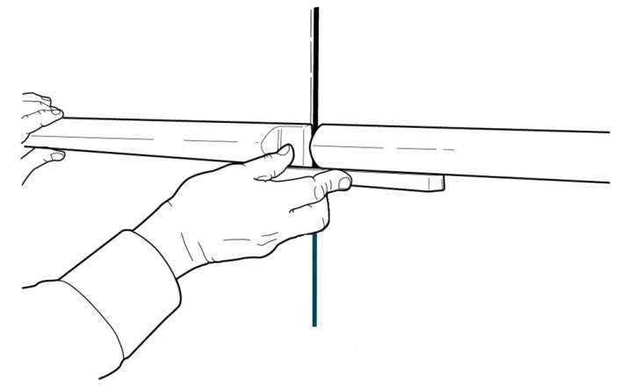
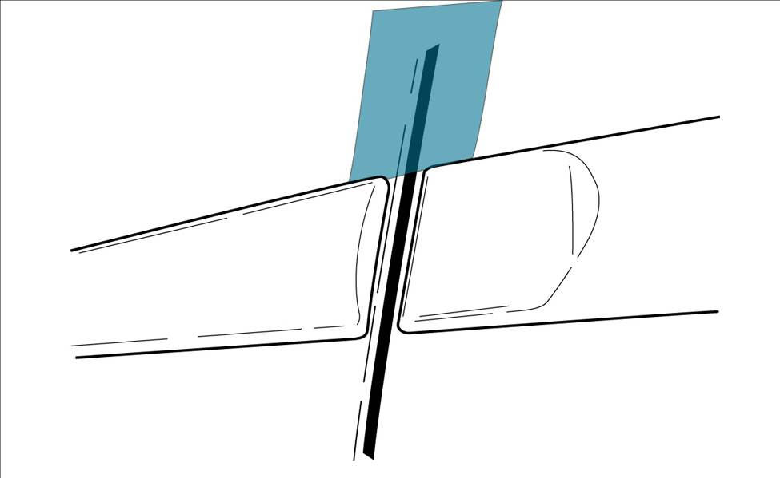
  - Repeat Steps 3(a) through 3(d) for the RH rear door molding placing the front edge of the molding 3.0 mm from the door edge as shown in Fig. 3-3 and Fig. 3-4.
Fig. 3-5
Fig. 3-4
RH Rear Molding
NOTE: To ensure vertical alignment where the rear and front molding meet between the doors, hold a plastic straight edge against the bottom of the front molding and use it as a guide for the rear molding as shown in Fig. 3-5. Tolerance for alignment in the vertical direction of the front and rear molding in relation to each other is 0.0mm +/-1.0mm.

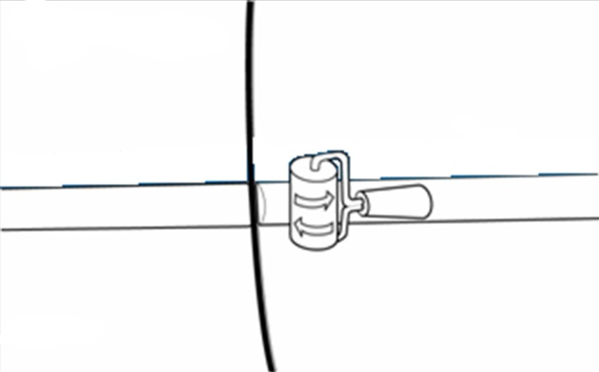
  - Use the hand roller and a clean cloth to roll around the perimeter of the parts with firm pressure to ensure complete adhesion of the tape to the door surface. Use the cloth to protect the sheet metal and the body side molding (Fig. 3-6).
Fig. 3-6
Hand Roller
  - Repeat the entire installation procedure for the other side of the vehicle.
  - Remove and discard all of the tape strips.

Accessory Function Checks
Check visual alignment

Check for proper tape adhesion.

Vehicle Function Checks
None Required

Vehicle Appearance Checks
After accessory installation and removal of protective cover(s), perform a visual inspection.

The moldings should be visually straight.
The front edge of the rear moldings should be 3.0 mm away from the front edge of the rear door.
The inside rear edge of the front moldings should be 6 mm away from the rear edge of the front doors.

Confirm 100% tape adhesion completely around the part between the Body Side Molding and door sheet metal.

Ensure no damage (including scuffs and scratches) was caused during the installation process. (For PPO installation, refer to Accessory Quality Shipping Standard.)

